SIMATS ENGINEERING
ASSESSMENT TOOL 3 – Assignment 2

COURSE NAME: STATISTICS WITH R PROGRAMMING COURSE CODE: ITA0408

COURSE OUTCOME COVERED
CO3: Construct and manipulate data frames using reshaping, merging, and file I/O operations in R to prepare structured datasets for analysis. (BL3, BL5)
Assessment Tool Weightage: 20%
QUESTIONS: 5 Total Marks: 100

Annexure
Assignment 2

Code of Conduct:

I Tamilarasan U (192525073) certify that this submission is my original work and that I have adhered to the guidelines specified for this assessment.
I understand that any violation of academic integrity rules will result in disciplinary action.
Tamilarasan U
Signature of the student:
Assignment 2:
- Generate 5 Questions for your Capstone Project module
- Apply the formulae and use the relevant graph to visualize it
- Upload the file in Github link
- Save the 5 Questions and Gihub link in the Excell sheet

1.Numerical Variable — Histogram
Question: How can the dashboard analyze the distribution of individual expense amounts?
Variable: Expense Amount — Numerical
R Code:
Expense Amount Histogram in R
expense_amount <- c(150, 250, 500, 300, 1200, 750, 400, 200,
1800, 600, 350, 900, 1500, 450, 700, 2500,
550, 800, 1000, 650)
hist(expense_amount,
breaks = 6,
col = "skyblue",
border = "black",
main = "Distribution of Expense Amounts",
xlab = "Expense Amount (Rs.)",
ylab = "Frequency")
A histogram showing how frequently expenses fall within different amount ranges.

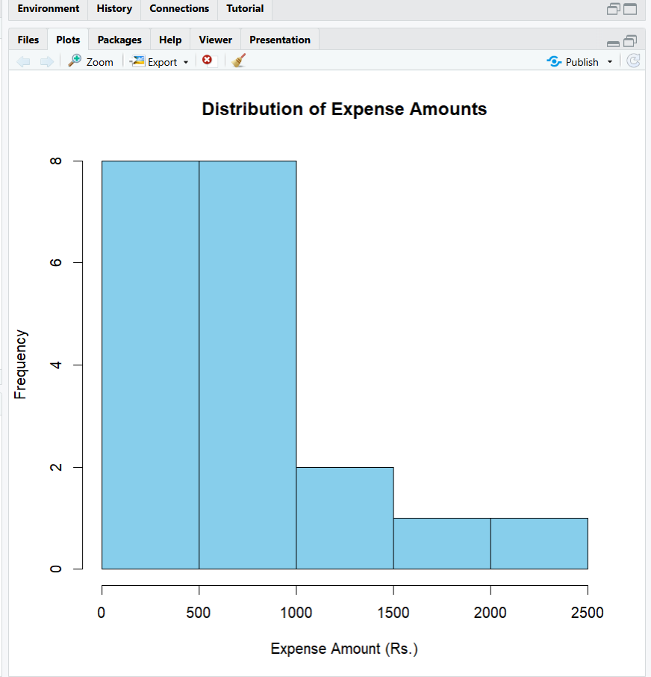

2: Two Categorical Variables — Grouped Bar Chart
How can the dashboard compare expense categories across different payment methods?
Variables:
- Expense Category — Categorical
- Payment Method — Categorical
- expense_category <- c("Food", "Travel", "Shopping", "Education", "Healthcare")
cash <- c(10, 5, 4, 3, 2)
upi <- c(15, 12, 8, 6, 5)
card <- c(6, 8, 10, 4, 3)
- expense_data <- rbind(cash, upi, card)
colnames(expense_data) <- expense_category
rownames(expense_data) <- c("Cash", "UPI", "Card")
- barplot(expense_data,
beside = TRUE,
col = c("blue", "green", "orange"),
main = "Expense Category by Payment Method",
xlab = "Expense Category",
ylab = "Number of Transactions",
legend.text = TRUE,
args.legend = list(title = "Payment Method"))
A grouped bar chart comparing Cash, UPI, and Card transactions across five expense categories.

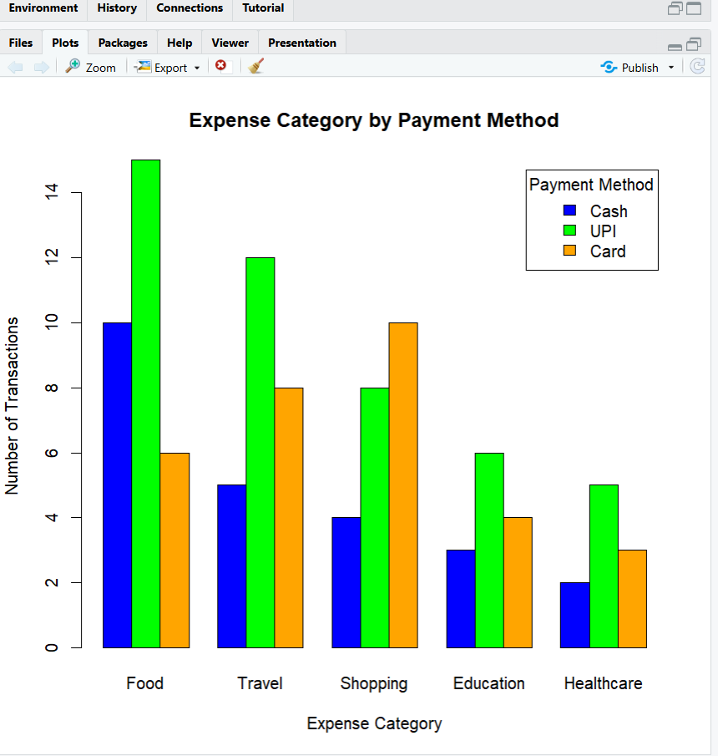
3. Two Numerical Variables — Scatter Plot
How can the dashboard analyze the relationship between monthly income and monthly expenses to identify spending patterns?
Variables:
- Monthly Income — Numerical
- Monthly Expenses — Numerical

R Code:
Monthly Income vs Expenses Scatter Plot in R
monthly_income <- c(20000, 25000, 30000, 35000, 40000,
45000, 50000, 55000, 60000, 65000)
monthly_expenses <- c(15000, 18000, 22000, 26000, 28000,
32000, 35000, 39000, 42000, 46000)
plot(monthly_income, monthly_expenses,
pch = 19,
col = "blue",
main = "Monthly Income vs Monthly Expenses",
xlab = "Monthly Income (Rs.)",
ylab = "Monthly Expenses (Rs.)")
abline(lm(monthly_expenses ~ monthly_income),
col = "red",
lwd = 2)
A scatter plot showing the relationship between monthly income and expenses. The red line represents the fitted linear trend.

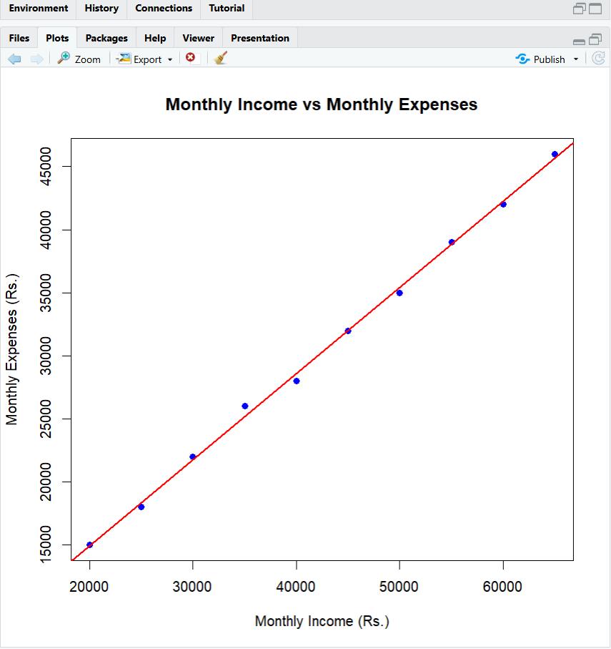
4: One Numerical + One Categorical Variable — Box Plot
How can the dashboard compare expense amounts across different categories?
Variables:
- Expense Amount — Numerical
- Expense Category — Categorical

R Code:
Expense Category Box Plot in R
category <- c("Food", "Food", "Food", "Food",
"Travel", "Travel", "Travel", "Travel",
"Shopping", "Shopping", "Shopping", "Shopping",
"Education", "Education", "Education", "Education",
"Healthcare", "Healthcare", "Healthcare", "Healthcare")
amount <- c(150, 250, 300, 500,
400, 800, 1200, 1500,
500, 900, 1200, 2000,
300, 600, 1000, 1800,
250, 700, 1100, 1600)
financial_data <- data.frame(category, amount)
boxplot(amount ~ category,
data = financial_data,
col = c("lightblue", "lightgreen", "orange", "pink", "yellow"),
main = "Expense Amount by Category",
xlab = "Expense Category",
ylab = "Expense Amount (Rs.)")

A box plot comparing the median, spread, and potential outliers of expenses across five categories.

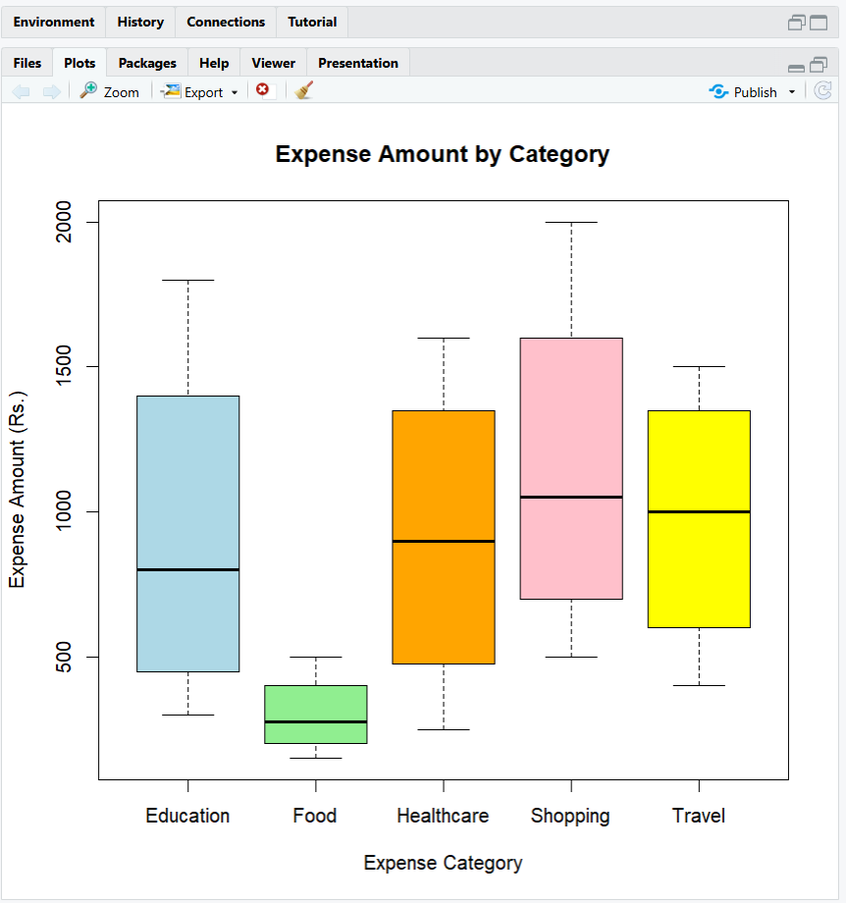

5.How can an interactive financial expense dashboard compare the monthly budget with actual monthly expenses to identify overspending and monitor budget performance?(Two Numerical -Line chart)

• Variable 1: Monthly Budget (Numerical)
• Variable 2: Actual Monthly Expenses (Numerical)
• Visualization: Line Chart
months <- c("Jan", "Feb", "Mar", "Apr", "May", "Jun")
monthly_budget <- c(10000, 12000, 11000, 15000, 14000, 16000)
actual_expenses <- c(9000, 13500, 10500, 16000, 12500, 17000)
plot(monthly_budget,
type = "o",
col = "blue",
pch = 16,
xaxt = "n",
ylim = range(c(monthly_budget, actual_expenses)),
xlab = "Month",
ylab = "Amount (Rs.)",
main = "Monthly Budget vs Actual Expenses")
axis(1, at = 1:6, labels = months)
lines(actual_expenses,
type = "o",
col = "red",
pch = 17)
legend("topleft",
legend = c("Monthly Budget", "Actual Expenses"),
col = c("blue", "red"),
lty = 1,
pch = c(16, 17))
The line chart will display two lines:
- Blue line: Monthly budget.
- Red line: Actual monthly expenses.

